**Make Infographics using Piktochart**

Piktochart is a freemium service. Certain features are only accessible for pay, but the basic features are enough to get started with infographics.

Activity folder:

Access the folder from <http://go.ncsu.edu/infographics>

Folder includes data set, icons (from [nounproject.com](https://thenounproject.com/))

Take a look at the data set

**Create a Piktochart account:**

Go to [piktochart.com](https://piktochart.com/)

Click on “Start for Free” or “Sign Up” and register using email address, Facebook, or Google Account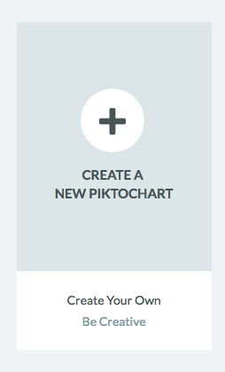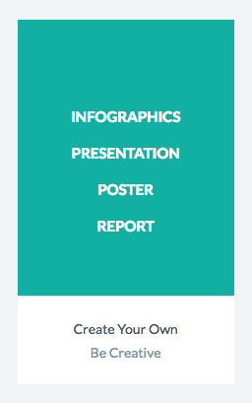

**Create a new Infographic:**

Select the “Create a New Piktochart”

Select the INFOGRAPHICS template

Piktochart works in blocks. This makes it easy to arrange and rearrange different sections of your infographic.

piktochart_4.png

**Make a title:**

Select the top block

From the toolbar, click on the “Back-Ground” icon and select a background color, image, or texture.

Click on the “Text” icon

**Upload images:**

Upload the 3 icons from the Icons Folder.

Piktochart will store uploaded images for future use in your account.

Select the top block, click on the icons to add

*\*You cannot edit uploaded images. Any changes (cropping, color change, etc.), must be done before the image is uploaded.*

**Search for Graphics:**

Piktochart has a library of shapes, icons, and images.

piktochart_5.png

**Text Block:**

Add a new block.

Add a textbox with the following text:

“For Centuries, humankind has argued over which pet is better, the Dog or the Cat. Data collected by the American Veterinary Medical Society shows which pet is more popular in the USA.”

**Maps:** 

Add a new block.

Select the Tools option from the left hand toolbar

Select the Maps option

Search for the United States

Edit the map by changing the color.

\**The map creation function is not robust. If a map is an important piece of data visualization, try using a different tool to create the map and then upload it as an image.*

**Charts:**

Select the Tools option from the left hand toolbar.

Select the Charts option

Copy and paste the totals table from the dataset. Select the Vertical Bar chart. 

You can edit the chart under the settings.

**Download and Share:**

With the free version, you can download a watermarked .png or .jpeg of the

infographic.

You can also publish the infographic to the web, and share it.

Example: <https://magic.piktochart.com/output/16440282-cats-vs-dogs>

**More help:**

<https://www.youtube.com/user/Piktochart>